EMBARGOED UNTIL 06.01 AM JAKARTA MONDAY 19 SEPTEMBER 2022

Can Indonesia really achieve a net zero electricity sector by 2040?

[Jakarta, 19 September 2022] A mini briefing from global energy think tank Ember reveals the many benefits of accelerating clean energy transition in Indonesia, in response to a much-awaited report released early this month by the International Energy Agency (IEA) on “Energy Sector Roadmap to Net Zero Emissions (NZE) in Indonesia”.

It’s all about electricity. The mini briefing shows that by far the biggest and quickest emissions cuts come from the electricity sector. And this means no unabated coal by 2040.

As the largest coal generating country in ASEAN, and among top 10 globally, Indonesia’s unabated coal will need to be phased out by 2040. This effort would need to start this decade. In the 2050 NZE scenario, coal-fired generation in 2030 would be 70% lower than the announced pledges scenario due to the high flexibility of coal power leading to less operational time.

Ember's mini briefing also highlights that the annual electricity sector investment should be tripled in this decade to reach almost USD 40 billion, and increased by eightfold in the following decade to around USD 80 billion, compared to 2010s; around 50% of which should be placed on renewable energy development.

While Indonesia’s Ministry of Energy and Mineral Resources targets renewables investment of around USD 36 billion, or USD 7 billion per year until 2025, this is insufficient and needs to increase to USD 20 billion per year until 2030. Much of this investment should be particularly allocated to solar and wind, followed by investment in flexible grid technology.

The benefits are clear. With more renewables in place, energy costs will come down. Clean energy investment will pay dividends in the long term in the form of lower fuel bills. On top of that, the net gains of the energy sector employment could reach 265,000 green jobs. Just energy transition policies will be crucial to ensure inclusivity and mitigate the risks of the transition process.

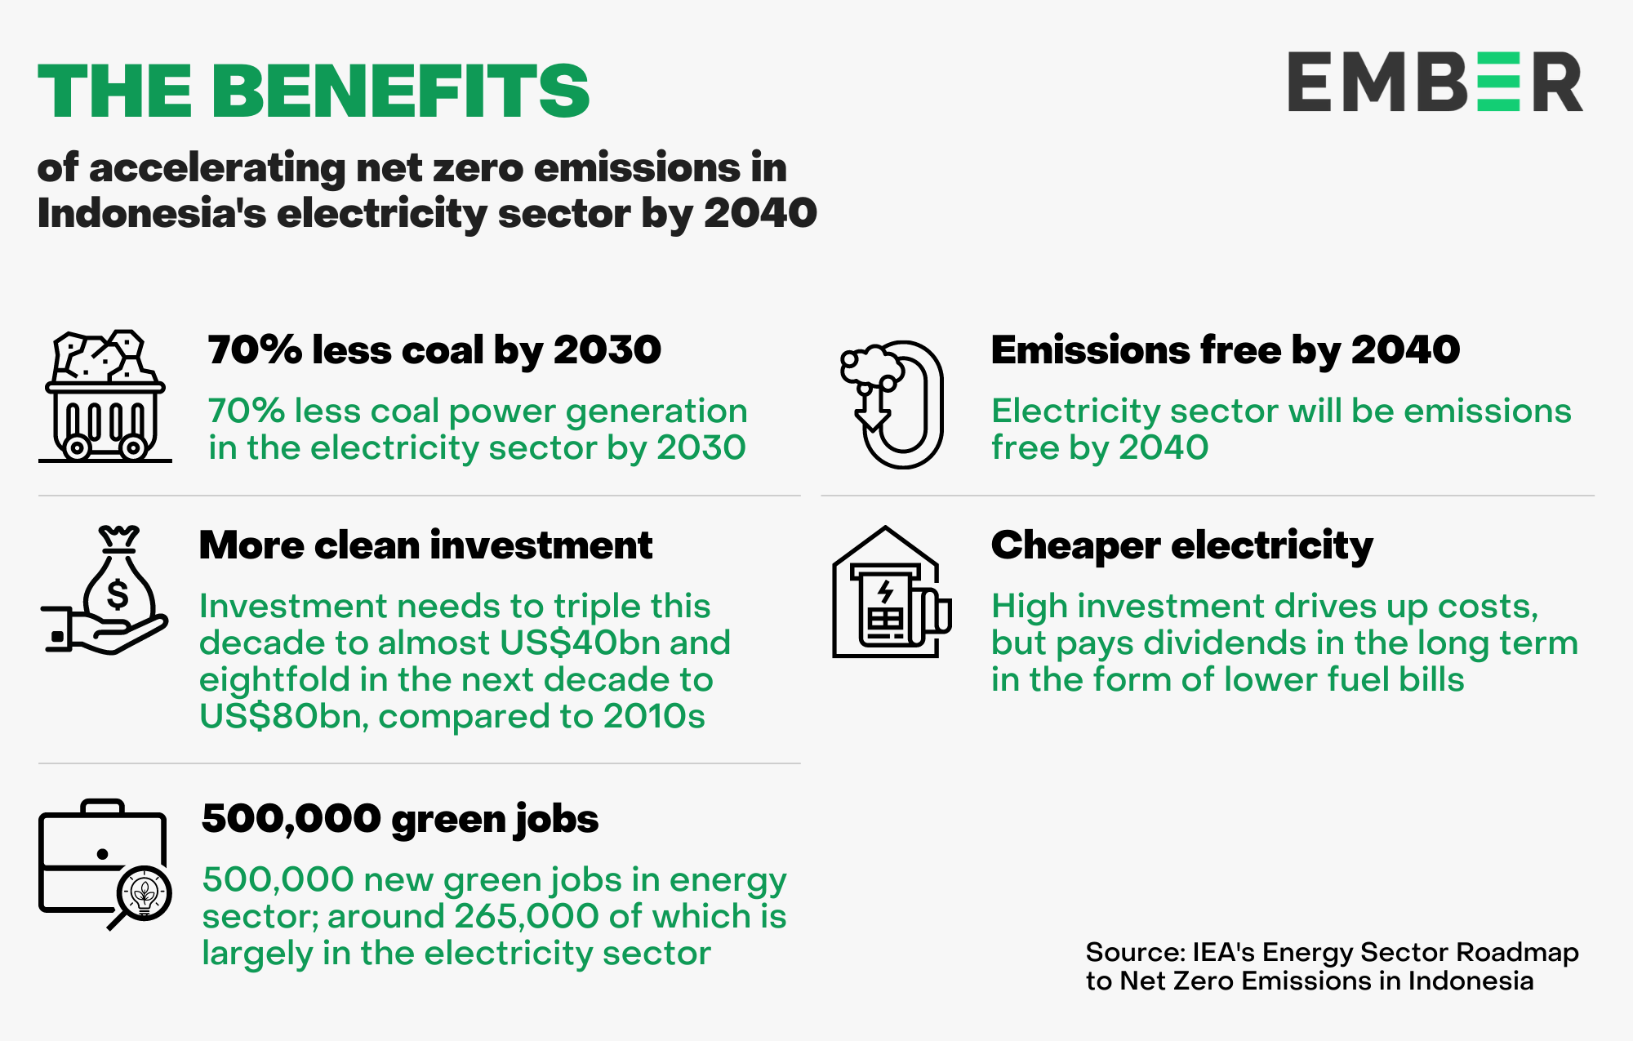

Transition to clean energy is technically possible for Indonesia due to an abundance of renewable energy sources. Indonesia has a high technical potential of large-scale solar and wind, around 1,462 GW and 500 GW respectively.

However, several challenges exist, including current electricity system operations under the state-owned electricity company, PT PLN, which hinder its ability to adapt with high penetration of variable renewable energy such as solar and wind. Another challenge is the mismatch between renewable energy sources and demand centres. Inter-regional connectivity among the main islands will be the key to overcoming this particular challenge.

The IEA report shows a promising future and the benefits of achieving decarbonization of the electricity system in Indonesia. The success of other sectors achieving NZE by 2050 will likely depend on the electricity sector's success to achieve it first by 2040.

All of this is possible and desirable. Lessons learned from other countries are available. It just needs the political ambition to match it.

Ember’s Asia Electricity Analyst, Dr Achmed Shahram Edianto, said:

“Renewables, especially solar and wind, are breaking records around the world, providing widely available lessons to reshape existing energy systems. It is possible for Indonesia to decarbonise by 2040 and provide a sustainable, affordable and secure energy supply. It just needs integration of government vision, political commitment and the implementation.”

- Ends -

The mini-briefing will be published online on Monday, 19 September 2022 at:
https://ember-climate.org/insights/commentary/can-indonesia-really-achieve-a-net-zero-electricity-sector-by-2040

Interview contact
Dr Achmed Shahram Edianto
Asia Electricity Analyst, Ember
achmed@ember-climate.org

Media enquiries
Rini Sucahyo
Asia Communications Manager, Ember
rini@ember-climate.org
+62 8111 800741

About Ember
Ember is an independent, not-for-profit climate and energy think tank that produces cutting-edge research and high impact, politically viable policies that aim to accelerate the global transition from coal to clean electricity.

https://ember-climate.org/
@EmberClimate

