

STRICTLY EMBARGOED UNTIL 08:01 AM KUALA LUMPUR ON WEDNESDAY 7 AUGUST 2024

**Solar generation in Peninsular Malaysia cost 53% lower than fossil fuels in 2023**

*Kuala Lumpur, 28 July 2024 -* Malaysia can achieve affordability and security benefits through rapid solar growth, according to a new [analysis](https://ember-climate.org/insights/research/solar-and-grid-flexibility-critical-for-malaysia) by global energy think tank Ember. The report finds **solar generation in Peninsular Malaysia was 53% cheaper than fossil fuels in 2023**.

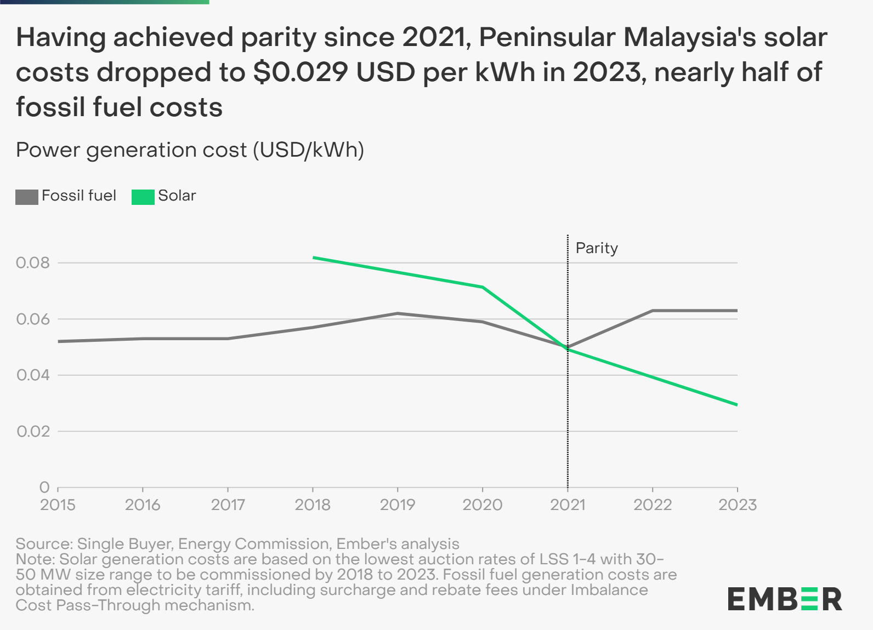

The report examines Malaysia’s electricity transition roadmap, focusing on maximising solar potential through targeted policies for faster solar growth and battery storage. It evaluates electricity trends in Peninsular Malaysia, Sabah and Sarawak, highlighting opportunities and challenges to meet renewable energy targets.

Approximately half of Malaysia’s solar power potential (138 GW) is in Peninsular Malaysia, while 37% (99 GW) is in Sabah and 12% (32 GW) is in Sarawak. Almost all of this solar resource is currently untapped.

Peninsular Malaysia, which accounts for 74% of the country's electricity demand, had solar and hydropower supplying 10% of daytime peak generation in 2023, with hydro providing 7% of the evening peak. The report also finds that Peninsular Malaysia’s grid can technically accommodate an additional 2.4 GW of solar before storage systems are needed.

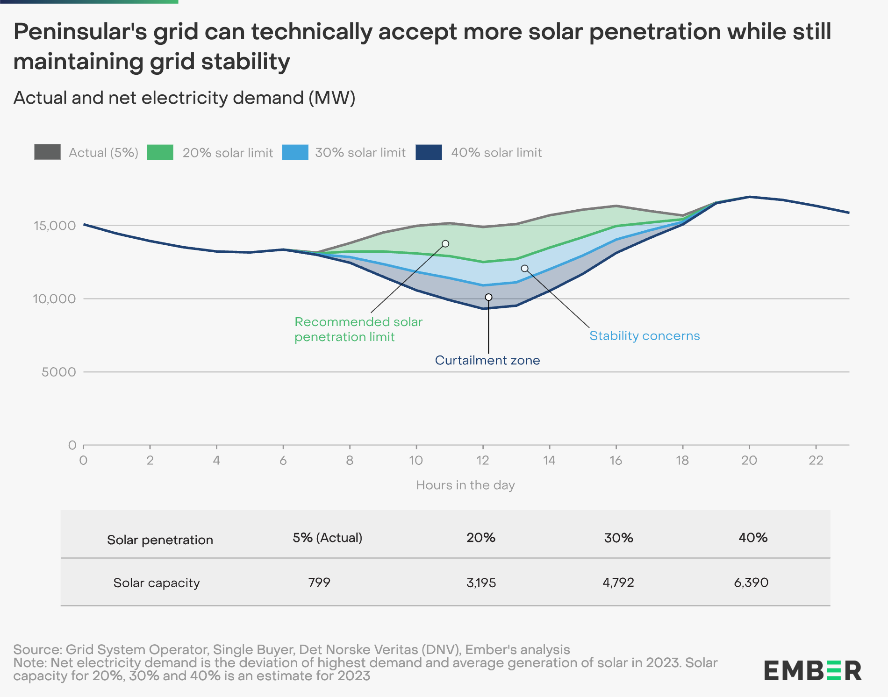

Peninsular Malaysia also saw bid prices from solar auctions drop significantly in 2023. From 2016 to 2021, the lowest auction rates for solar plants fell by 64%, from $0.082 USD per kWh to $0.029 USD per kWh. This aligns with a global decrease in solar generation costs of 55%. As the auctioned plants in 2021 were scheduled to start operating between 2022 and 2023, solar generation costs in the region had dropped to $0.029 USD per kWh by 2023, making them **53% cheaper than fossil fuels** at $0.063 USD per kWh.

**Promoting rapid solar growth will result in cost savings and improved energy security**

The country’s National Energy Transition Roadmap (NETR) targets 70% renewable capacity in the energy mix by 2050, with solar power expected to be the dominant source. However, this report suggests that **95% of Malaysia's massive solar potential will remain untapped in 2035** after solar is built as per NETR.

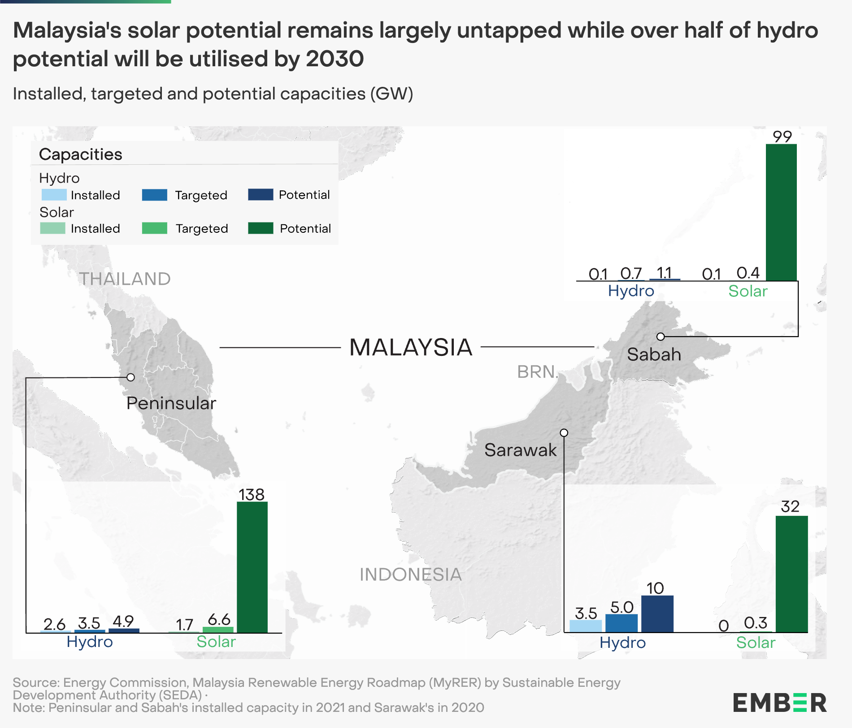

Ember estimates that by 2050, renewables will contribute about 52% of Malaysia’s energy, with gas making up the remaining 48%. This reliance on gas could make Malaysia’s power sector vulnerable to global fuel price volatility and domestic reserve depletion.

To mitigate these risks, raising renewable energy ambitions to further diversify Malaysia's power mix is essential, focusing on abundant solar resources to gain affordability and security benefits. Additionally, policies integrating solar and battery storage will enhance Malaysia’s energy transition.

Supporting rapid solar growth in Peninsular Malaysia, Sabah and Sarawak will also help meet the national power transition targets. In addition, integrating the grids of these regions will improve grid stability and power supply security, reducing reliance on fossil fuels.

**Shabrina Nadhila**, **Ember's Electricity Policy Analyst for Southeast Asia**, says, "The 64% reduction in utility-scale solar generation costs in Malaysia from 2016 to 2021 presents a significant opportunity to expedite the country’s journey towards achieving net zero ambitions in its power sector. By adopting holistic system-wide plan targeting solar and grid flexibility, Malaysia can accelerate its transition to clean energy, thereby reducing its vulnerability to fuel price volatility and mitigating the risk of becoming a net importer of power generation fuels."

**Prof. Yuen Yoong Leong of Sunway University**, who also serves as the **Director of Sustainability Studies at the UN Sustainable Development Solutions Networks (SDSN) Asia Headquarters**, adds, “Accelerating solar adoption and enhancing grid reliability necessitate the integration of Malaysia's grids. This strategy should extend beyond national borders through strategic ASEAN interconnections, prioritising regional collaboration over isolated national expansion. By fostering a unified energy market, we can optimise resource allocation, reduce costs and bolster grid resilience.”

**Dr. Nora Yusma binti Mohamed Yusoff, Director of the Institute of Energy Policy**, and **Researcher at Universiti Tenaga Nasional**, concludes, “Overcoming significant challenges in integrating high levels of solar power and implementing effective solar firming is crucial for ensuring grid stability and reliability. Despite the high cost, investing in energy storage solutions such as battery energy storage systems (BESS) is critical. By strategically planning, embracing technological advancements, and promoting public-private cooperation, Malaysia has the potential to harness its immense solar resources and pave the way for a secure and resilient energy future.”

-ENDS-

STRICTLY EMBARGOED UNTIL 08:01 AM KUALA LUMPUR ON WEDNESDAY 7 AUGUST 2024

**Notes to Editor**

The report will be published here at 08:01 AM Kuala Lumpur on Wednesday 7 August 2024:

<https://ember-climate.org/insights/research/solar-and-grid-flexibility-critical-for-malaysia>

[Media Pack](https://drive.google.com/drive/folders/1lY4aDQjt3GqB7XdsIEXvNJ1ECzPMCdbe?usp=sharing) - including the press release, report, data and chart images

**Media enquiries**

Rini Sucahyo

Asia Communications Manager, Ember

[rini@ember-climate.org](mailto:rini@ember-climate.org)

+62 8111 800 741

**About Ember**

[Ember](https://ember-climate.org/) is an independent energy think tank that aims to accelerate the clean energy transition with data and policy. It creates targeted data insights to advance policies that urgently shift the world to a clean, electrified energy future. [@EmberClimate](https://x.com/EmberClimate)